How to use the SIMS SQL Database Diagnostic Tool to identify any learners (pupil/students) with incomplete contact addresses
The diagnostic output will list all incomplete addresses imported into SIMS after the Spring upgrade was applied. This includes incomplete addresses present in the CTF that were not affected by the issue.
An incomplete address is defined as an address that is missing the house name or number, apartment <Paon> number and postcode.
- Navigate to the SIMS installation folder and run DBDiagnose.exe
e.g. C:\Program Files\SIMS\SIMS .net.\DBDiagnose.exe
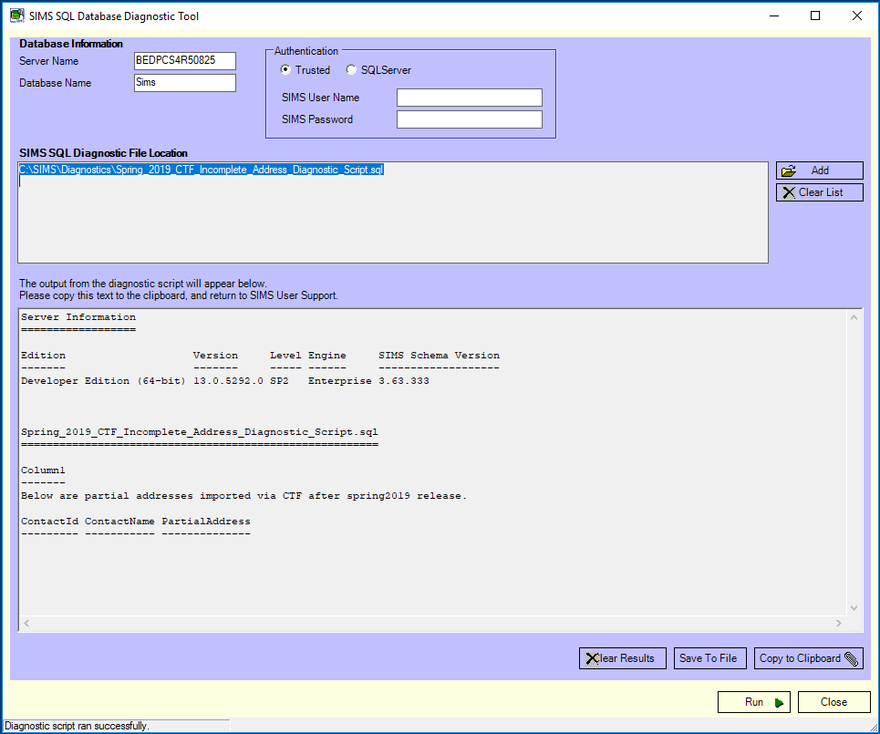

- From the Database Information panel, enter the Server Name and the Database Name
e.g. Server1\GreenAbbey.

- Select the Authentication method from the appropriate radio button.
When the SQL Server radio button is selected, the SIMS User Name and SIMS Password fields will be activated.

- Complete the SIMS User Name and SIMS Password fields, where applicable.

- Click the Add button in the SIMS SQL Diagnostic File Location panel to display the Windows Open dialog and navigate to the location where you have saved “Spring_2019_CTF_Incomplete_Address_Diagnostic_Script.sql”.
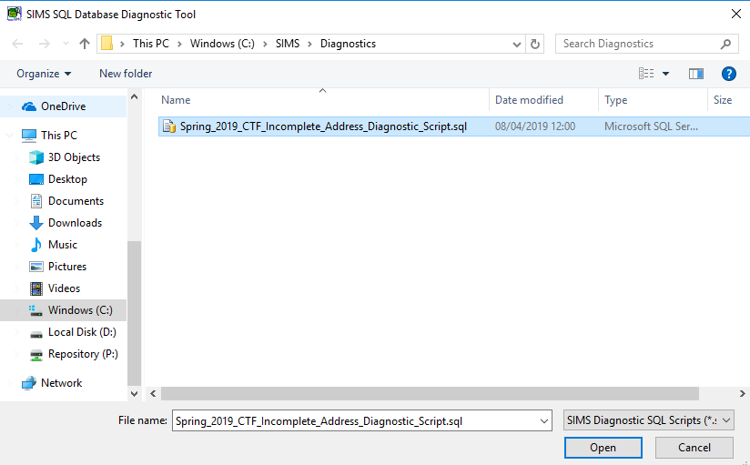
- Highlight “Spring_2019_CTF_Incomplete_Address_Diagnostic_Script.sql” and click the Open button.

- Click the Run button at the bottom of the page.

- When the script has finished checking the data, a message is displayed in the bottom left-hand side of the page advising that the Diagnostic script ran successfully.

- Contact ID, Contact Name and the incomplete address details will appear in the bottom panel of the utility. If there are no names or addresses present, as in the example screenshot below, no further action is required.
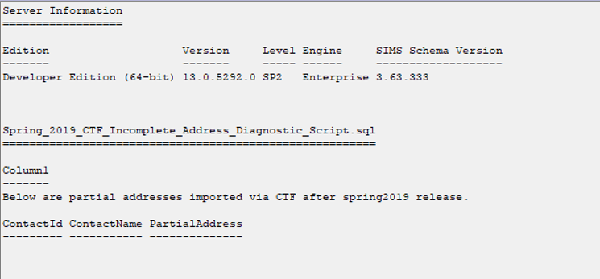

- If any names and addresses are present the output will contain contact information, as in the example screenshot below.
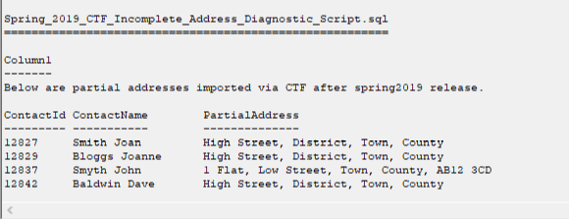

- To save the output, click the Save to File button to display the Save Diagnostic Results dialog. Navigate to a suitable storage location and identify the File name with the current date for ease of identification. The results will be stored as a .LOG file and can be viewed using Notepad (alternatively save as a .CSV file to view in Excel).

- Click the Close button to close the SIMS SQL Database Diagnostic Tool page.

- To find the contact in SIMS via the homepage, enter the number shown in the ContactId column from the diagnostic output into the quick search box, using braces { }. Double click the contact name to open the record.
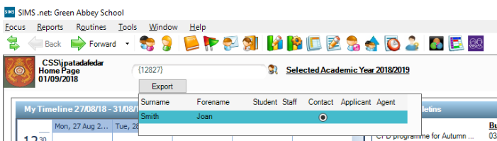

- Use Panel 3 on the contact record to check the address. The option to Delete or Modify Address can be chosen if changes are required.
