How to import a report definition file and run the report
Do not attempt to open the report definition file, these files are not written in a format that allows them to opened they need to be imported in to SIMS so they can be linked to your data and generated through the SIMS database. You will get an error message if you attempt to open it.
- Save the report files on your PC.

- Go to Reports | Import – click on open
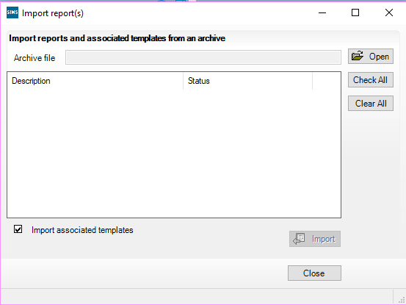

- Locate the file that you saved and either double click on it or click on open.
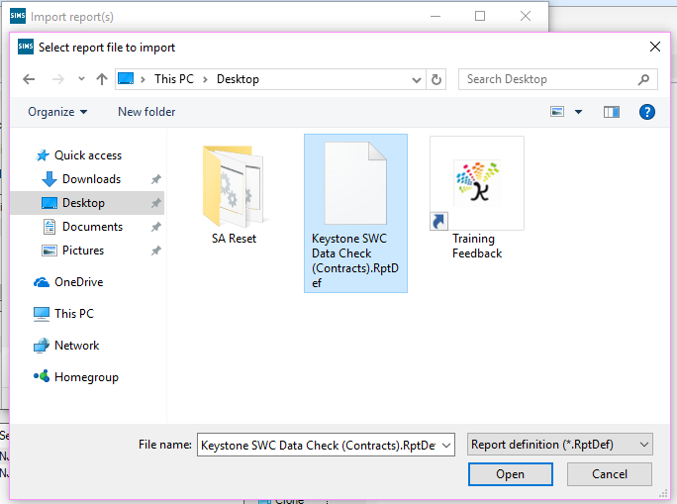

- Ensure you have selected the correct file and there is a tick next to the name. Click on Import – the status will change from pending to imported.
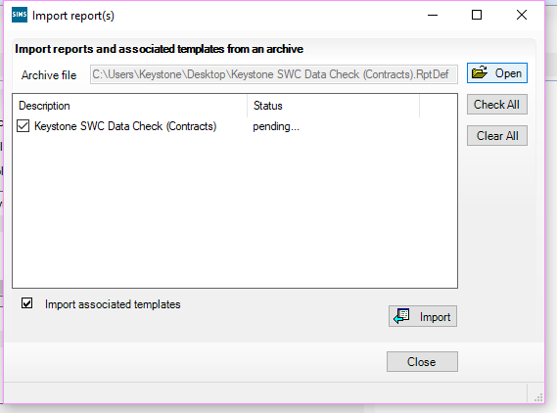
- Once the status has changed to imported, close the window.
- To run the report, go to Reports | Run report or use the run report icon .

- Click on the + next to the ‘Focus’ folder to expand this area. Select the staff folder by clicking on it. The right-hand side of your screen will show the reports that are available. Locate the report that you have just imported. If your list is long you can click once in the list of reports and start type K and you will be taken to any reports that start with K – our reports will be prefixed with Keystone.
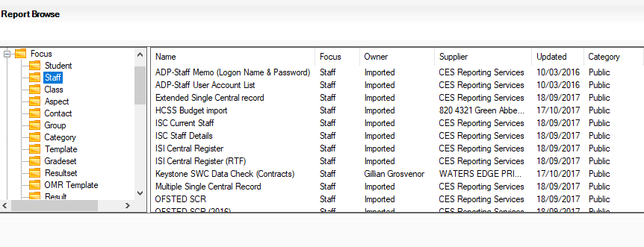
- If you click once on the report you will be able to see the export file type
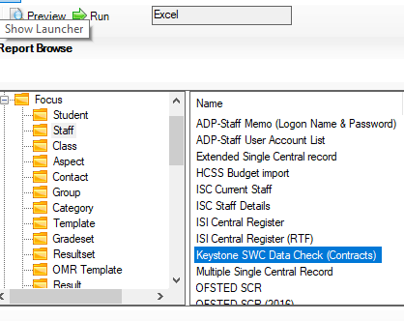
This file will output to an Excel document. To run the report double click on the name.

If the File does not open – look at your task bar at the bottom of the screen to locate the Excel icon and click on this to view the report.

- Your report will be available to use.

